**2015 Fall UMKC Hackathon**

**Title: Enhanced Weather Reporting for Travel Planning**

Project Document

By

GADEPALLI ANUSHA

HARSHA KOMALLA

YARRAGONDA HARSHI PRIYA

SWATHI ROBBI

**Introduction**

Enhanced Weather Reporting for Travel Planning is an app which allows users to view directions, weather, places to visit along the route and can choose the mode of transportation through which user wants to travel . Our app can be used by all the users who had registered. Every user can check distance, directions, places to visit along the route and weather before he/she travels. Necessary precautions can be taken by the travelers before their journey begins to have a happy and safe journey. To make their journey more entertaining, this app has the option of places nearby which displays all the best places to visit in their route.

**Objectives:**

The main objective of the project is to provide accurate details to the user about his/her journey. To make an memorable journey with all fun and safety.

**Import Existing Services/API:**

API to get weather for different places:

http://api.openweathermap.org/data/2.5/forecast/daily?q='+city+'&appid=2de143494c0b295cca9337e1e96b00e0&mode=json&units=metric&cnt=3&callback=JSON_CALLBACK

API to get nearby places:

<https://maps.googleapis.com/maps/api/js?sensor=false&libraries=places>

**WireFrames:**

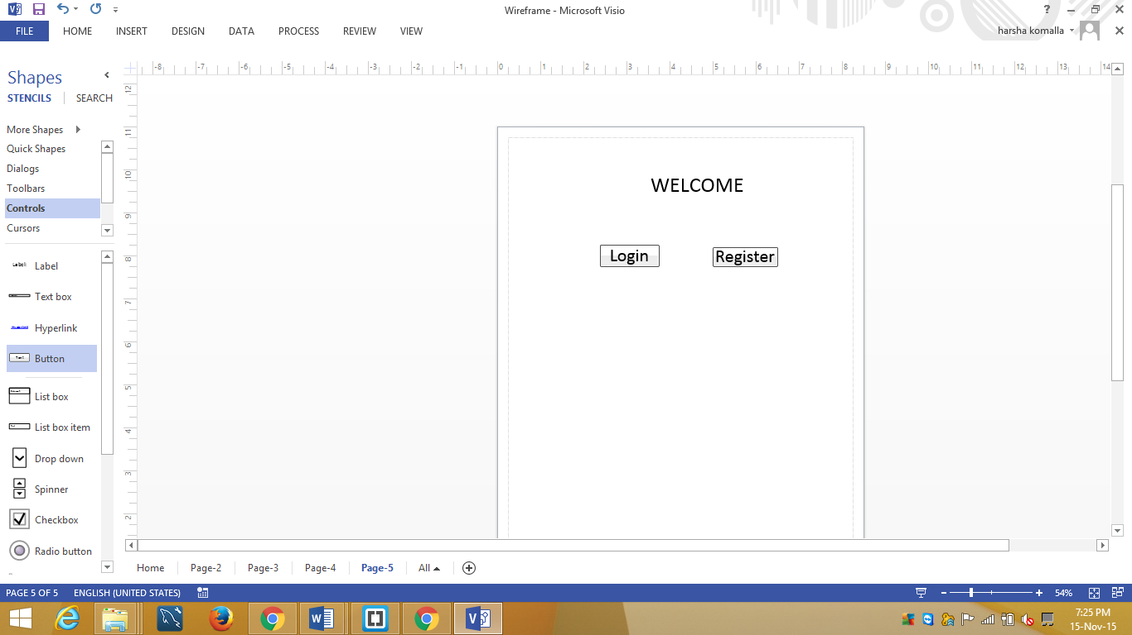

Fig1: First main page of the application. It has two options. New users need to register and then login. Registered users can directly login.

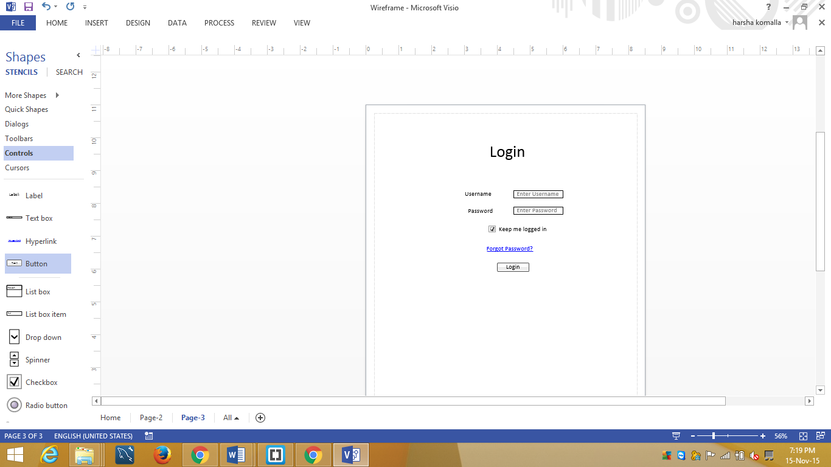

Fig2: This is the login page. If the user is a registered user then he/she can directly login into the application

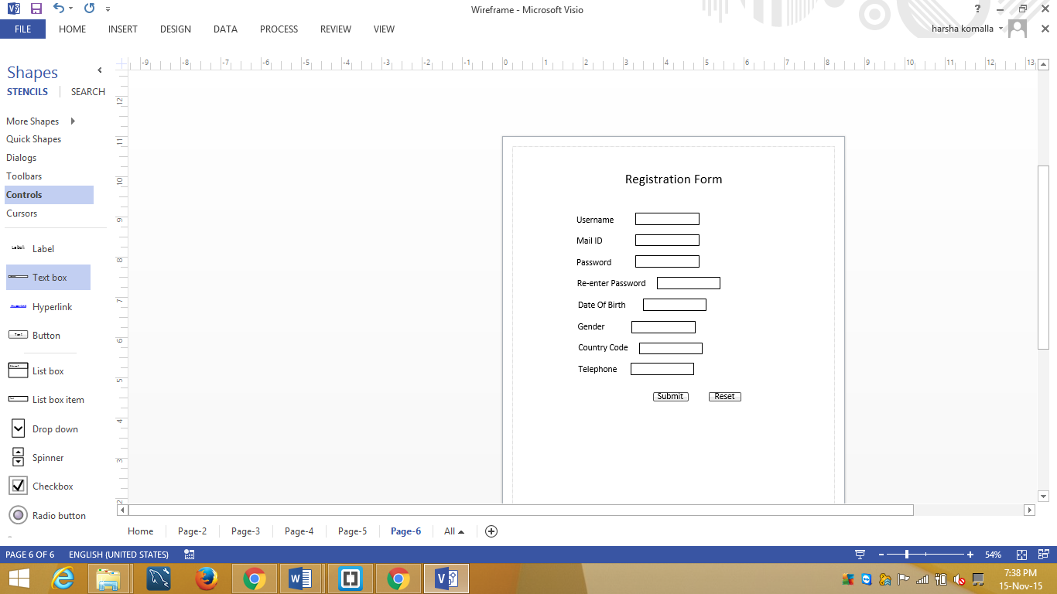

Fig3: This is the registration page. All the new users can register and then can logon.

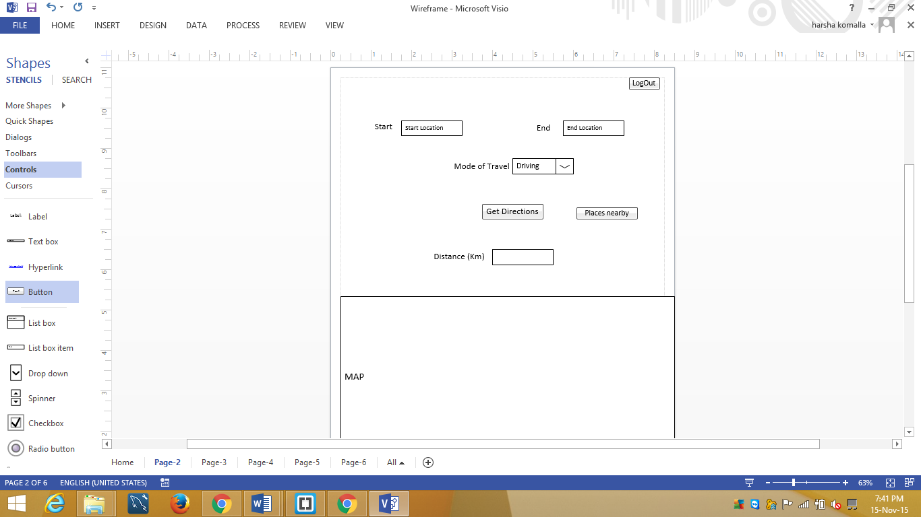

Fig4: After logining on, user will be able to see the above page, where the user can enter start and end location and can get directions, temperature and the places to visit along the route.

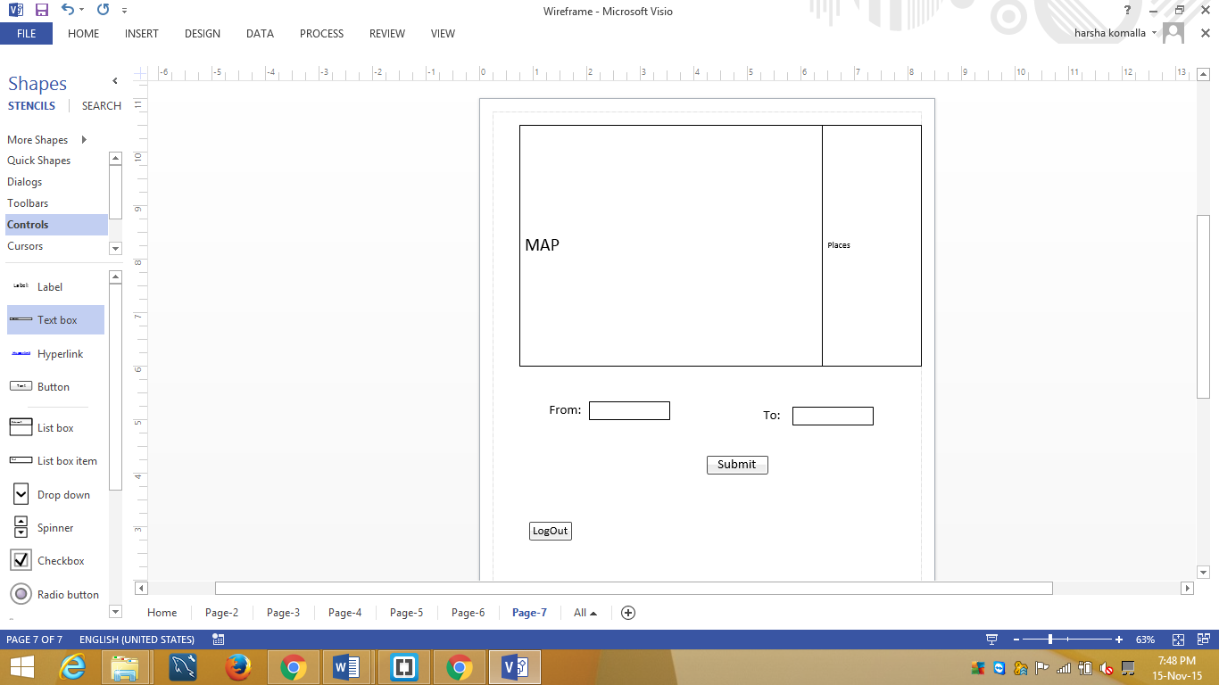

Fig5: When places nearby button is clicked, the above page displays. In this page you can know all the places in the route.

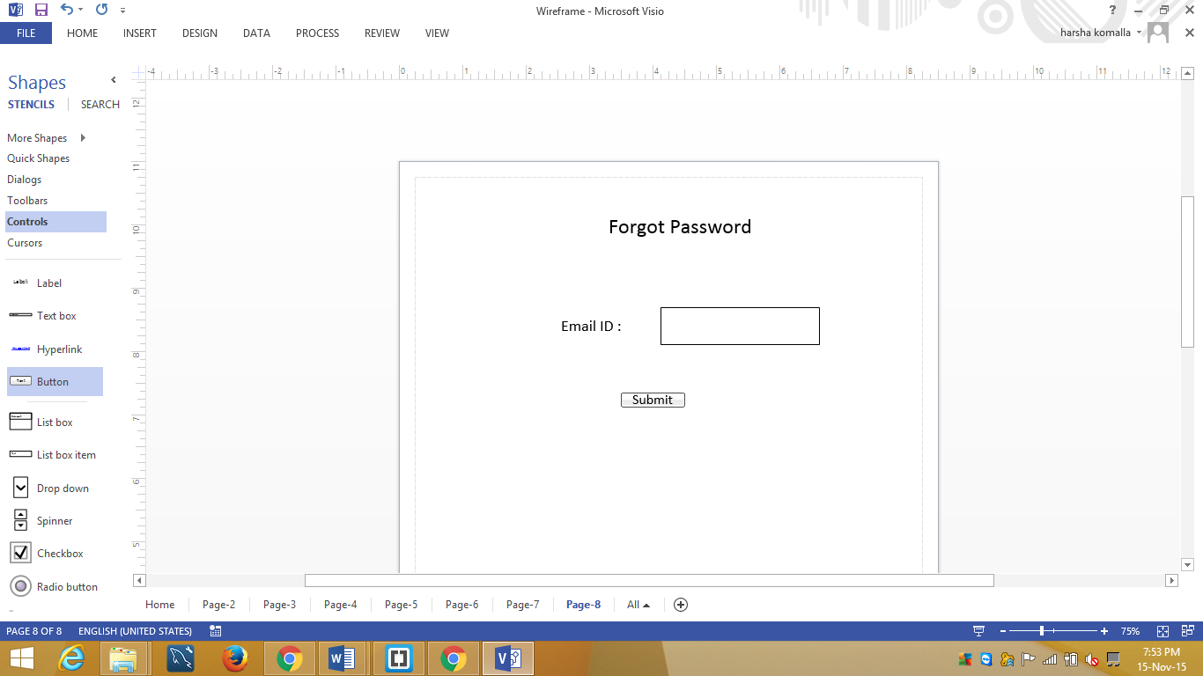

Fig6 : when the user forgets the password then he/she can click on forgot password link then it displays the page. In this page you need to enter your email address and then click on submit button then a link will be send to the given email ID with the help of that you can login.

**Mockups:**

1. **Main home page:**

When the users open the application, this page displays.

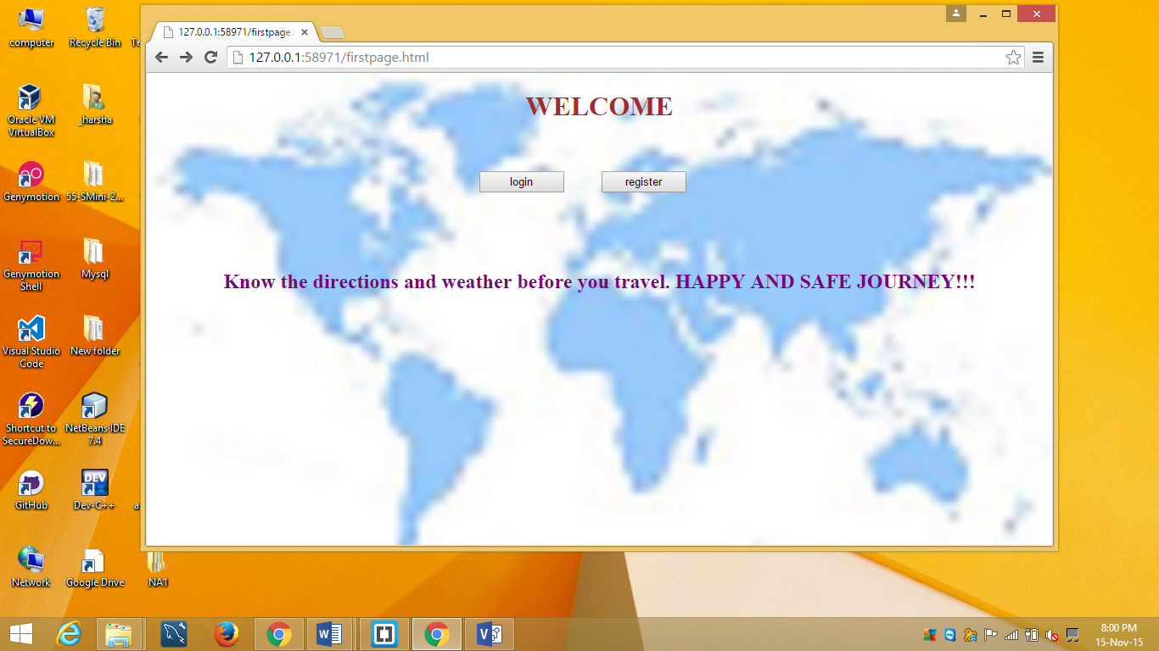

1. **Registration page:**

The user need to register in order to use the application.

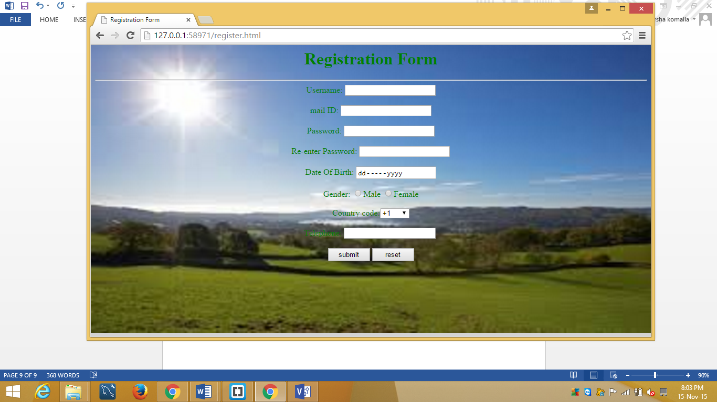

1. **Login page:**

After registration, the user can login and use the application.

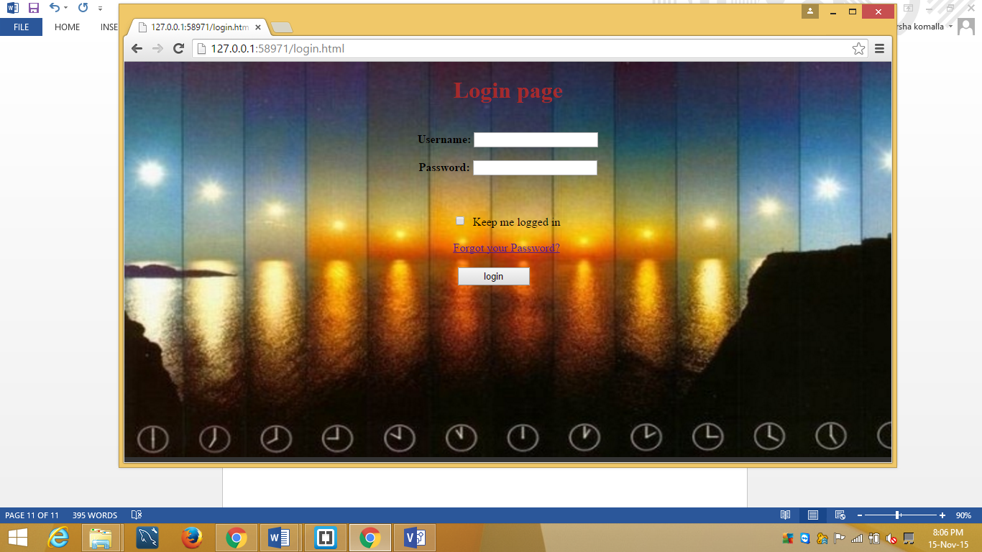

1. **Home page:**

After login, the home page displays which contains the options to get distance, places to visit on the route, mode of travel and weather.

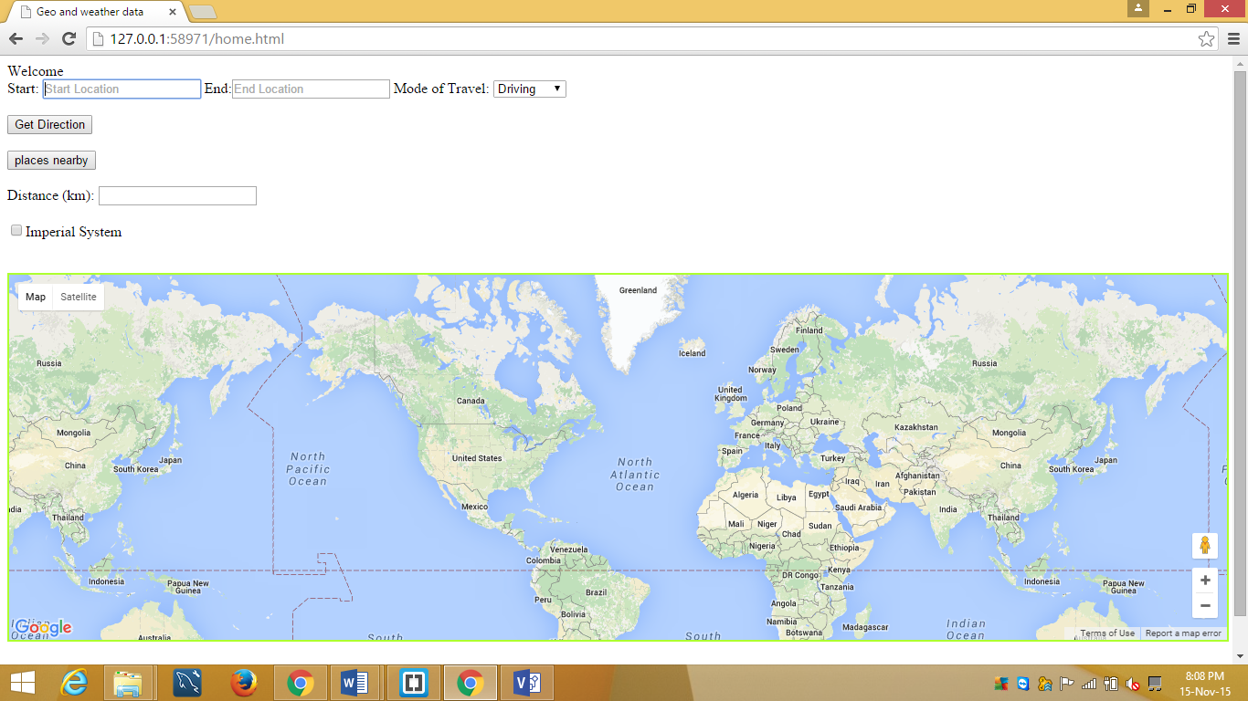

After entering the start, end location and selecting the mode of travel, the results will be displayed.

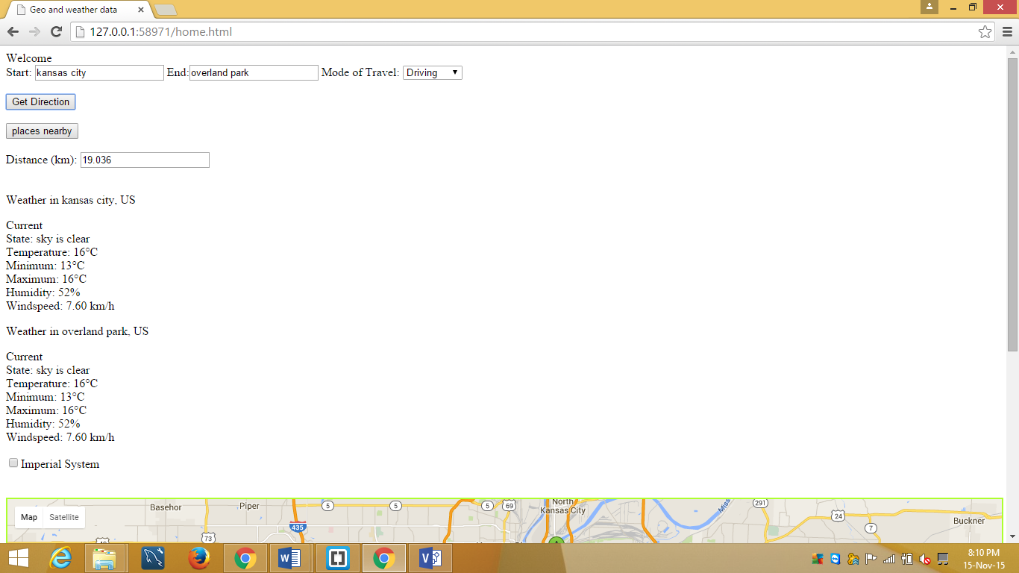

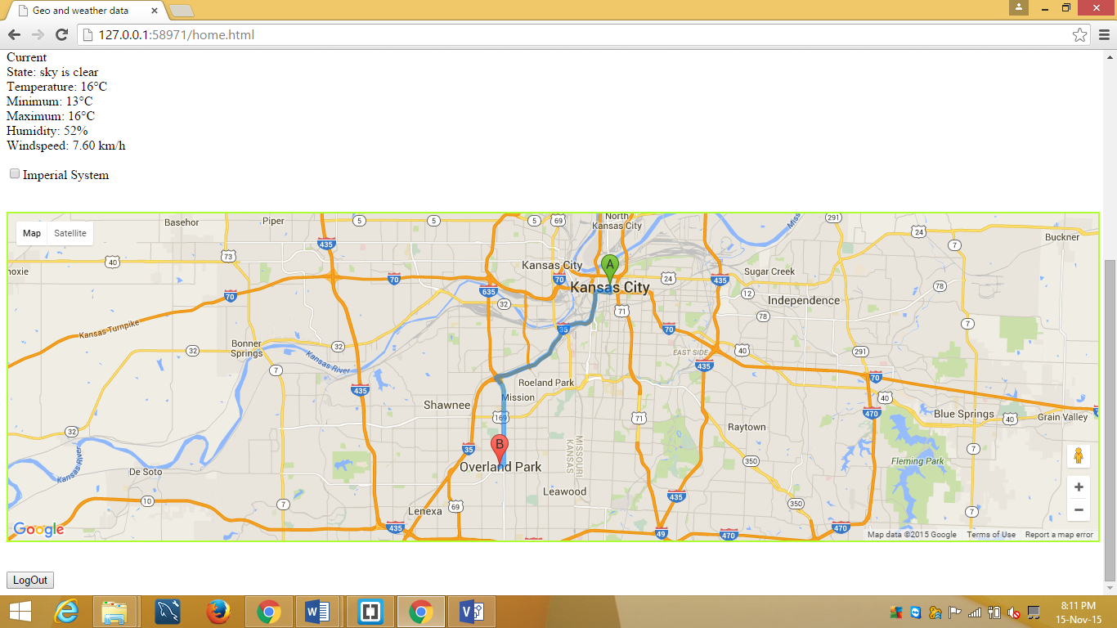

1. **Places nearby:**

The places which are in the route are displayed and the details along with address, telephone number are displayed.

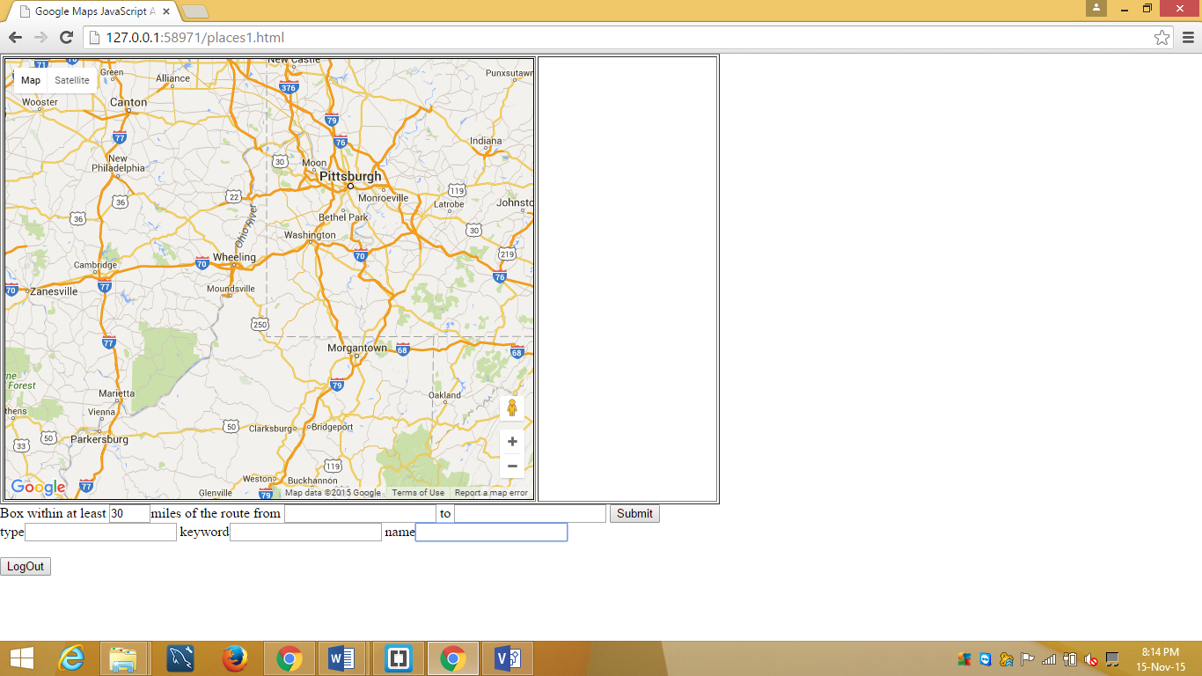

After entering the start and end address and by selecting the type of places needed such as McDonald’s, recreation centers etc users can get the details.

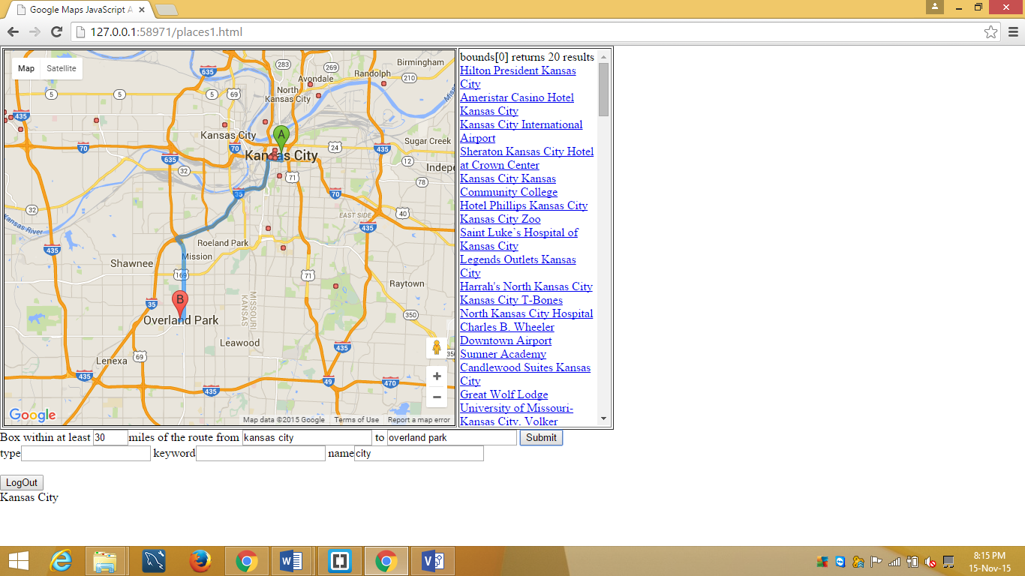

If the user wants to logout, then they can logout and then it opens the main page which consists of login and register buttons.

1. **Forgot Password:**

If user forgot his/her password then they can click on the button which helps in resetting their password. User need to give their email address, and on clicking submit button a mail will be sent to their mail which helps them to login.

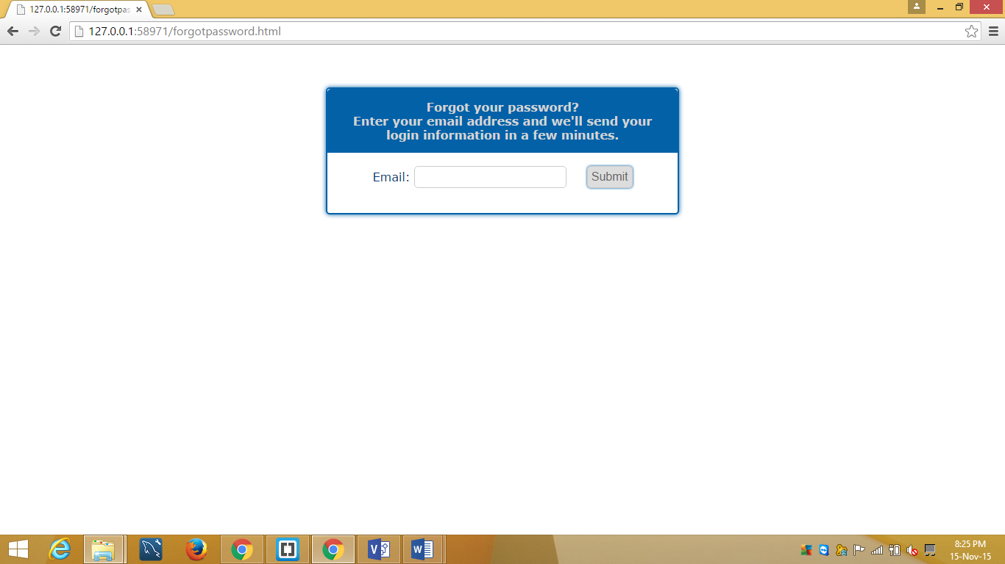

Youtube link: https://youtu.be/URFGFufVjBo